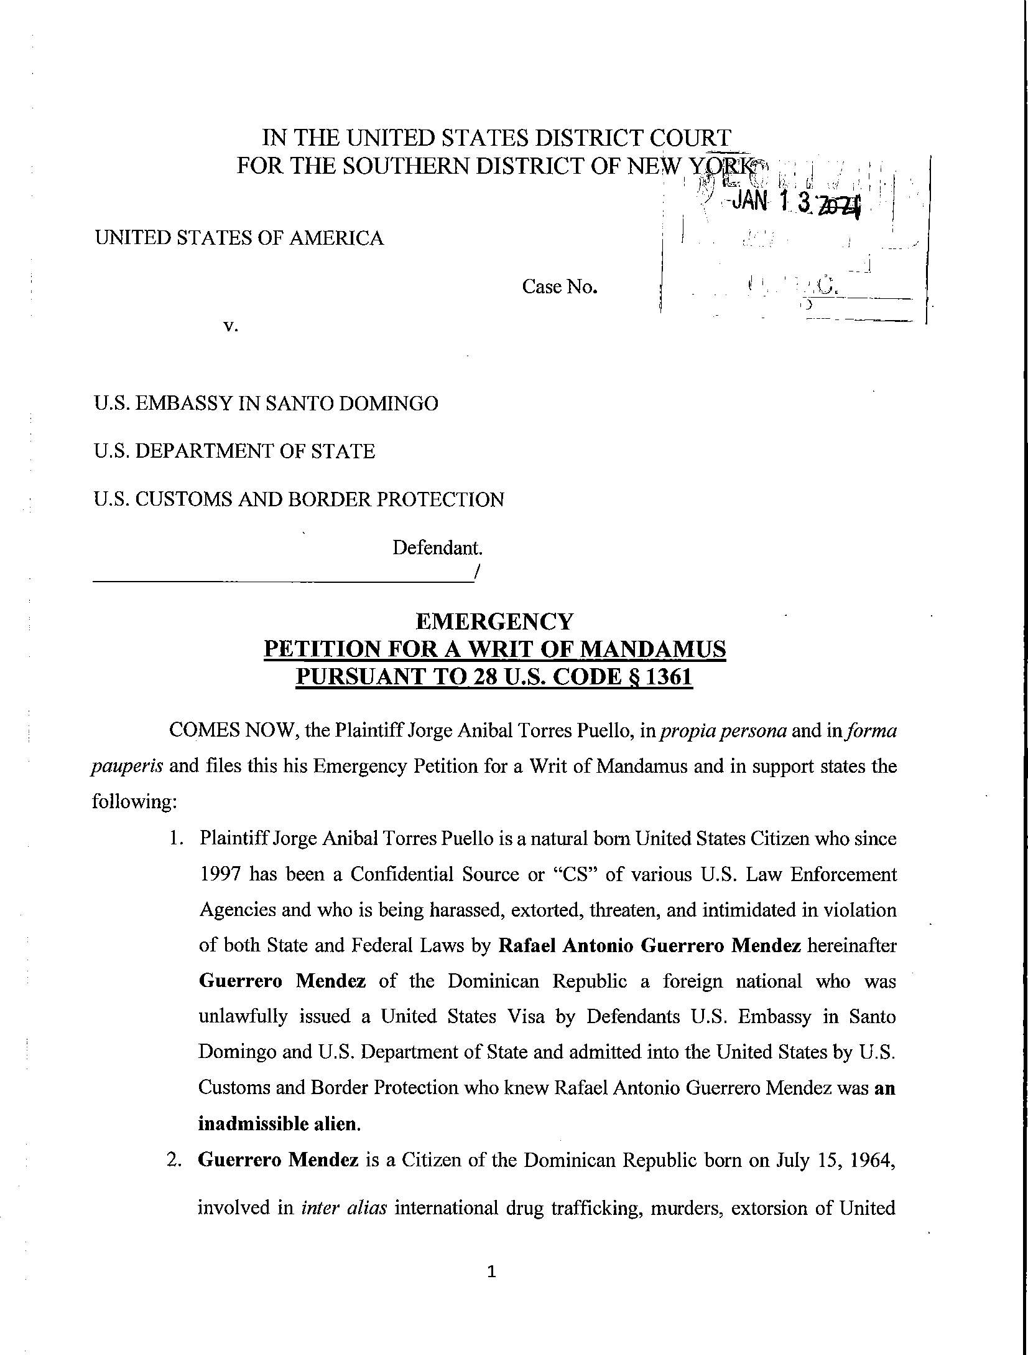
Case 1:21-cv-00292-UA Document 2 Filed 01/13/21 Page 1 of 25

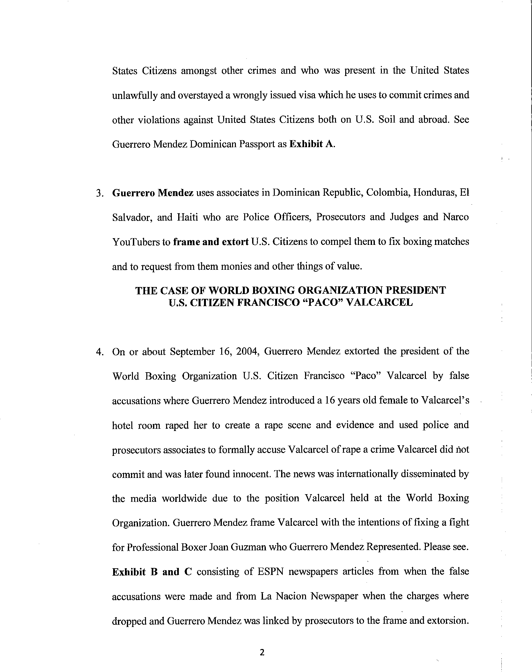
Case 1:21-cv-00292-UA Document 2 Filed 01/13/21 Page 2 of 25

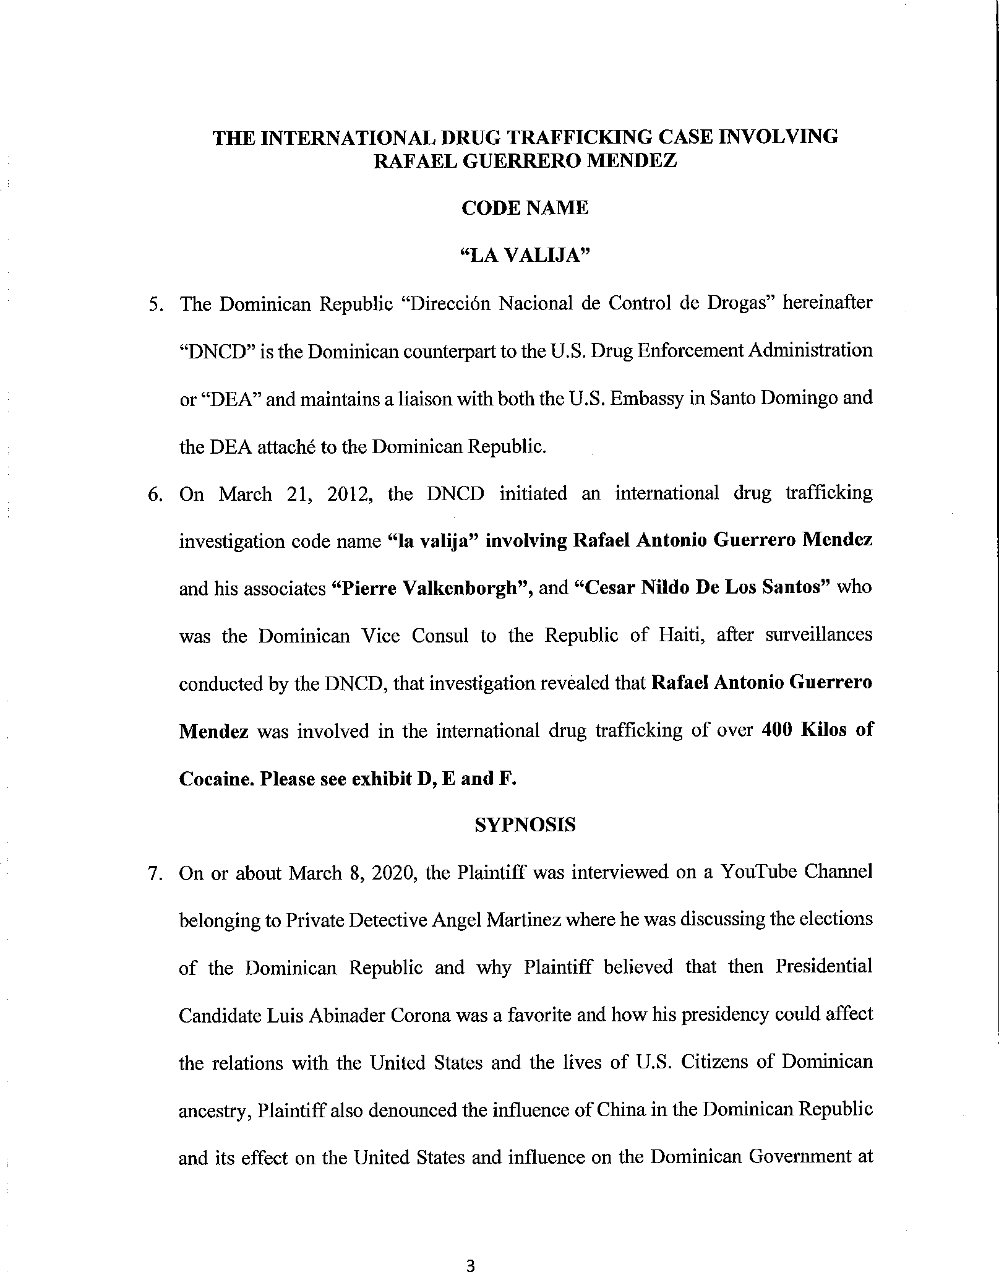
Case 1:21-cv-00292-UA Document 2 Filed 01/13/21 Page 3 of 25

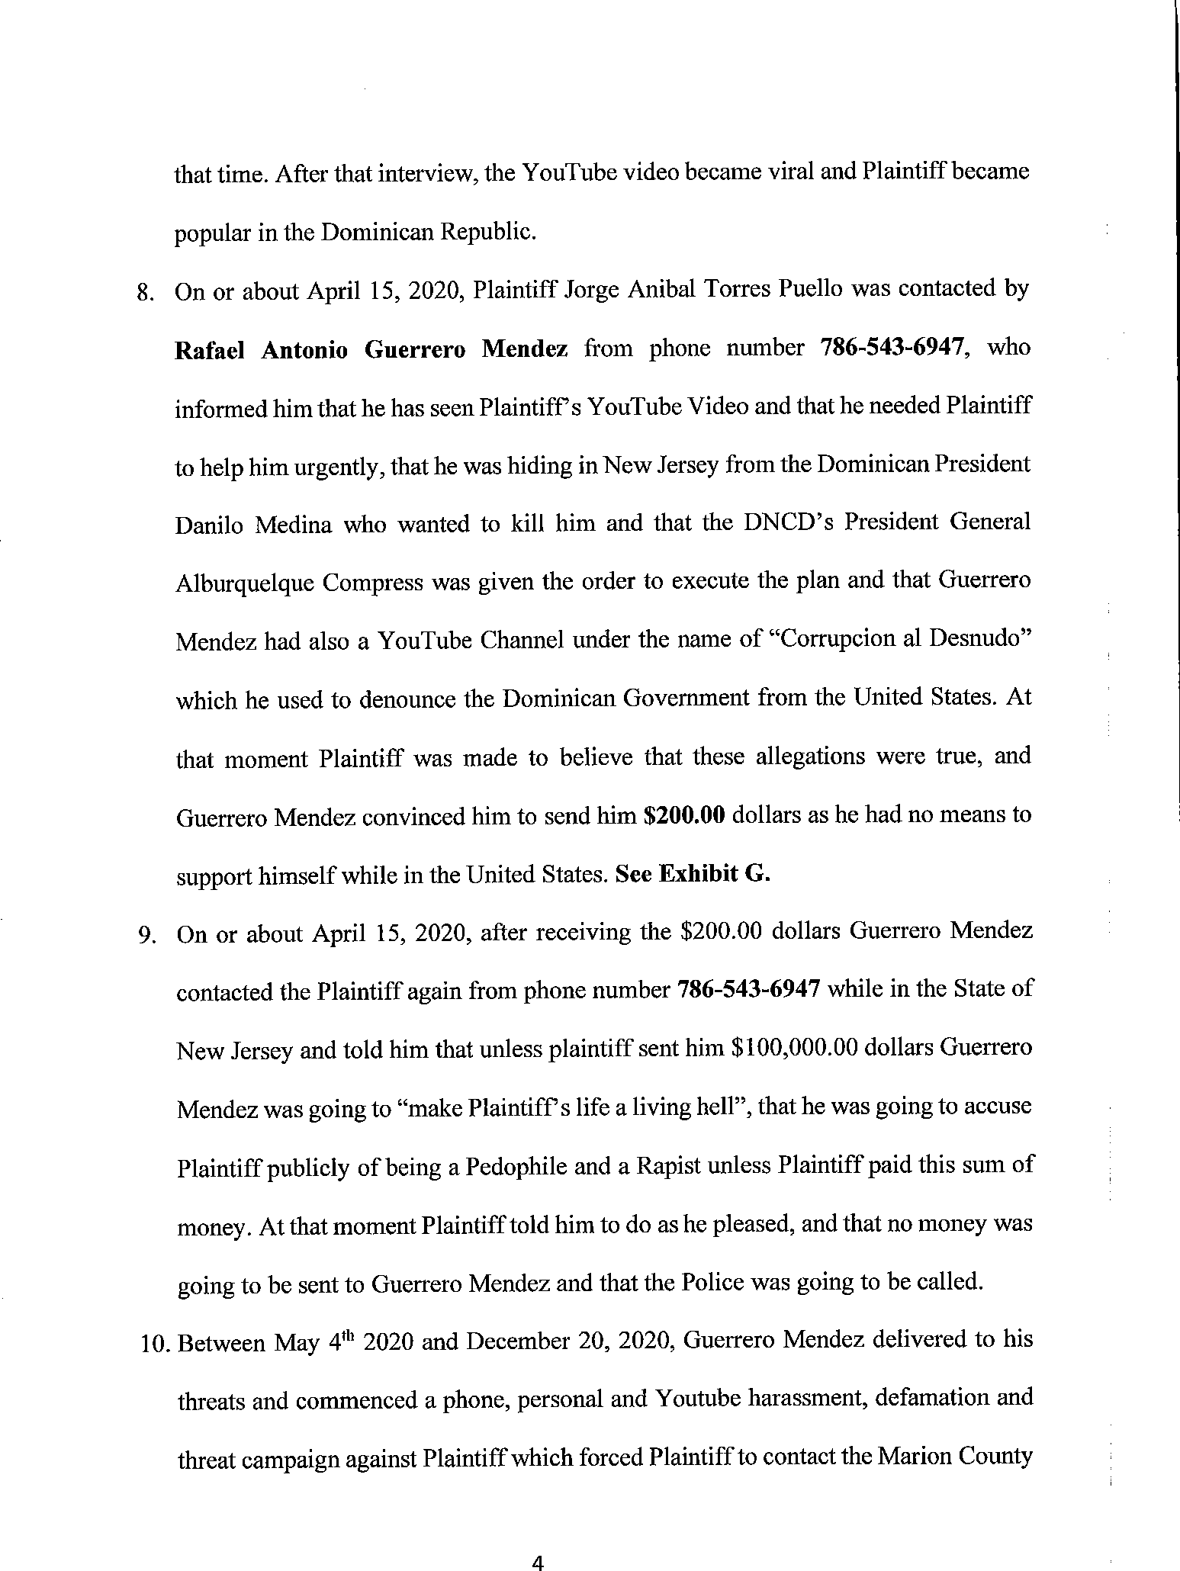
Case 1:21-cv-00292-UA Document 2 Filed 01/13/21 Page 4 of 25

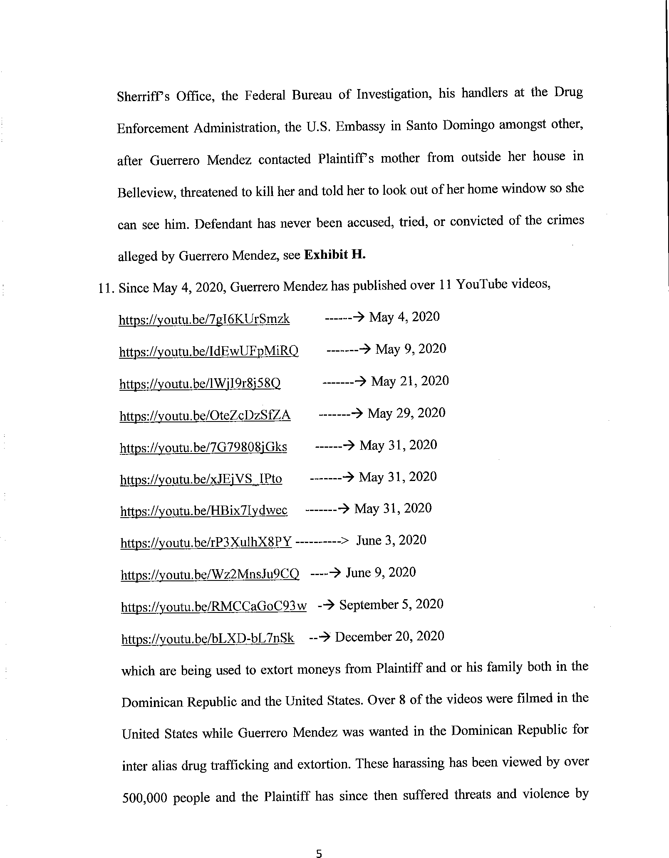
Case 1:21-cv-00292-UA Document 2 Filed 01/13/21 Page 5 of 25

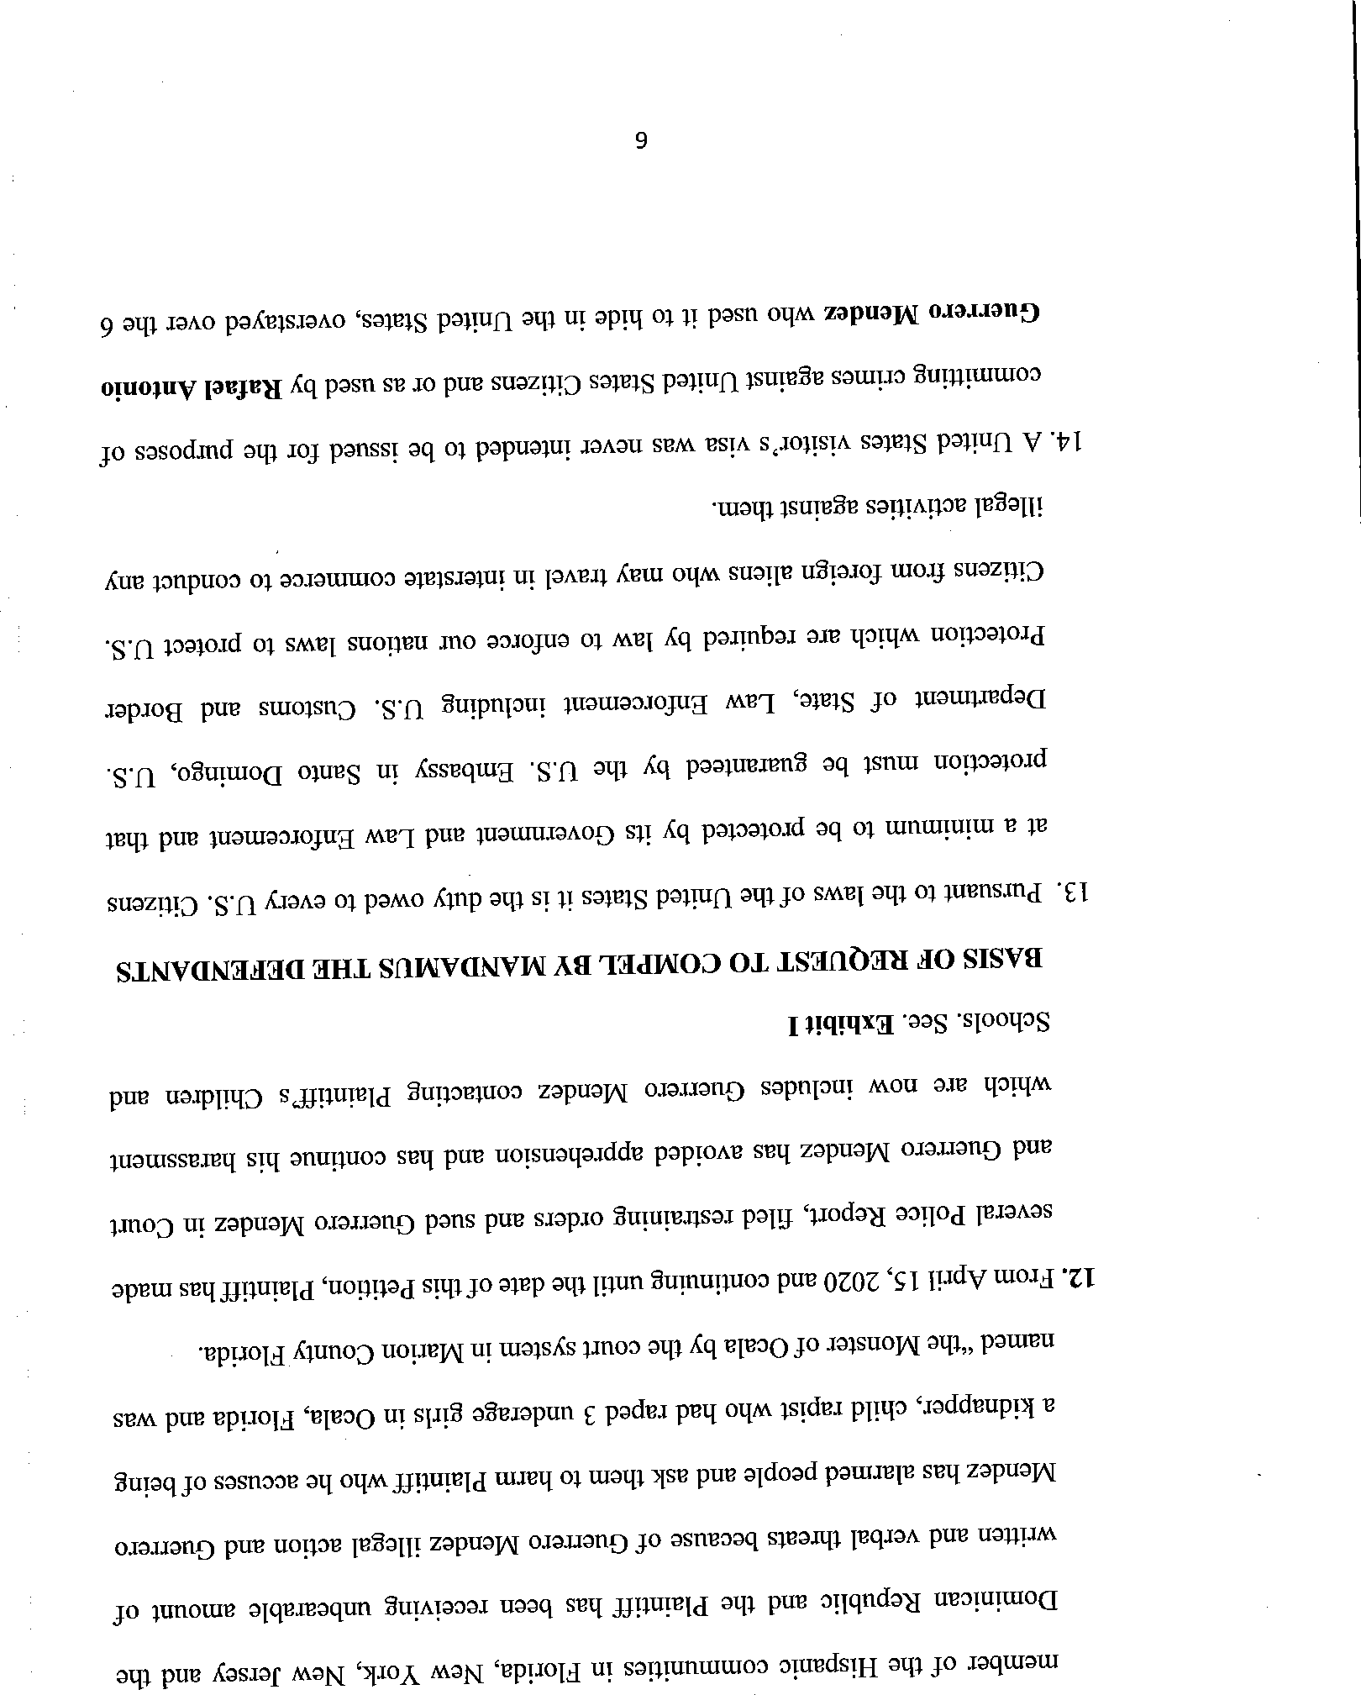
Case 1:21-cv-00292-UA Document 2 Filed 01/13/21 Page 6 of 25

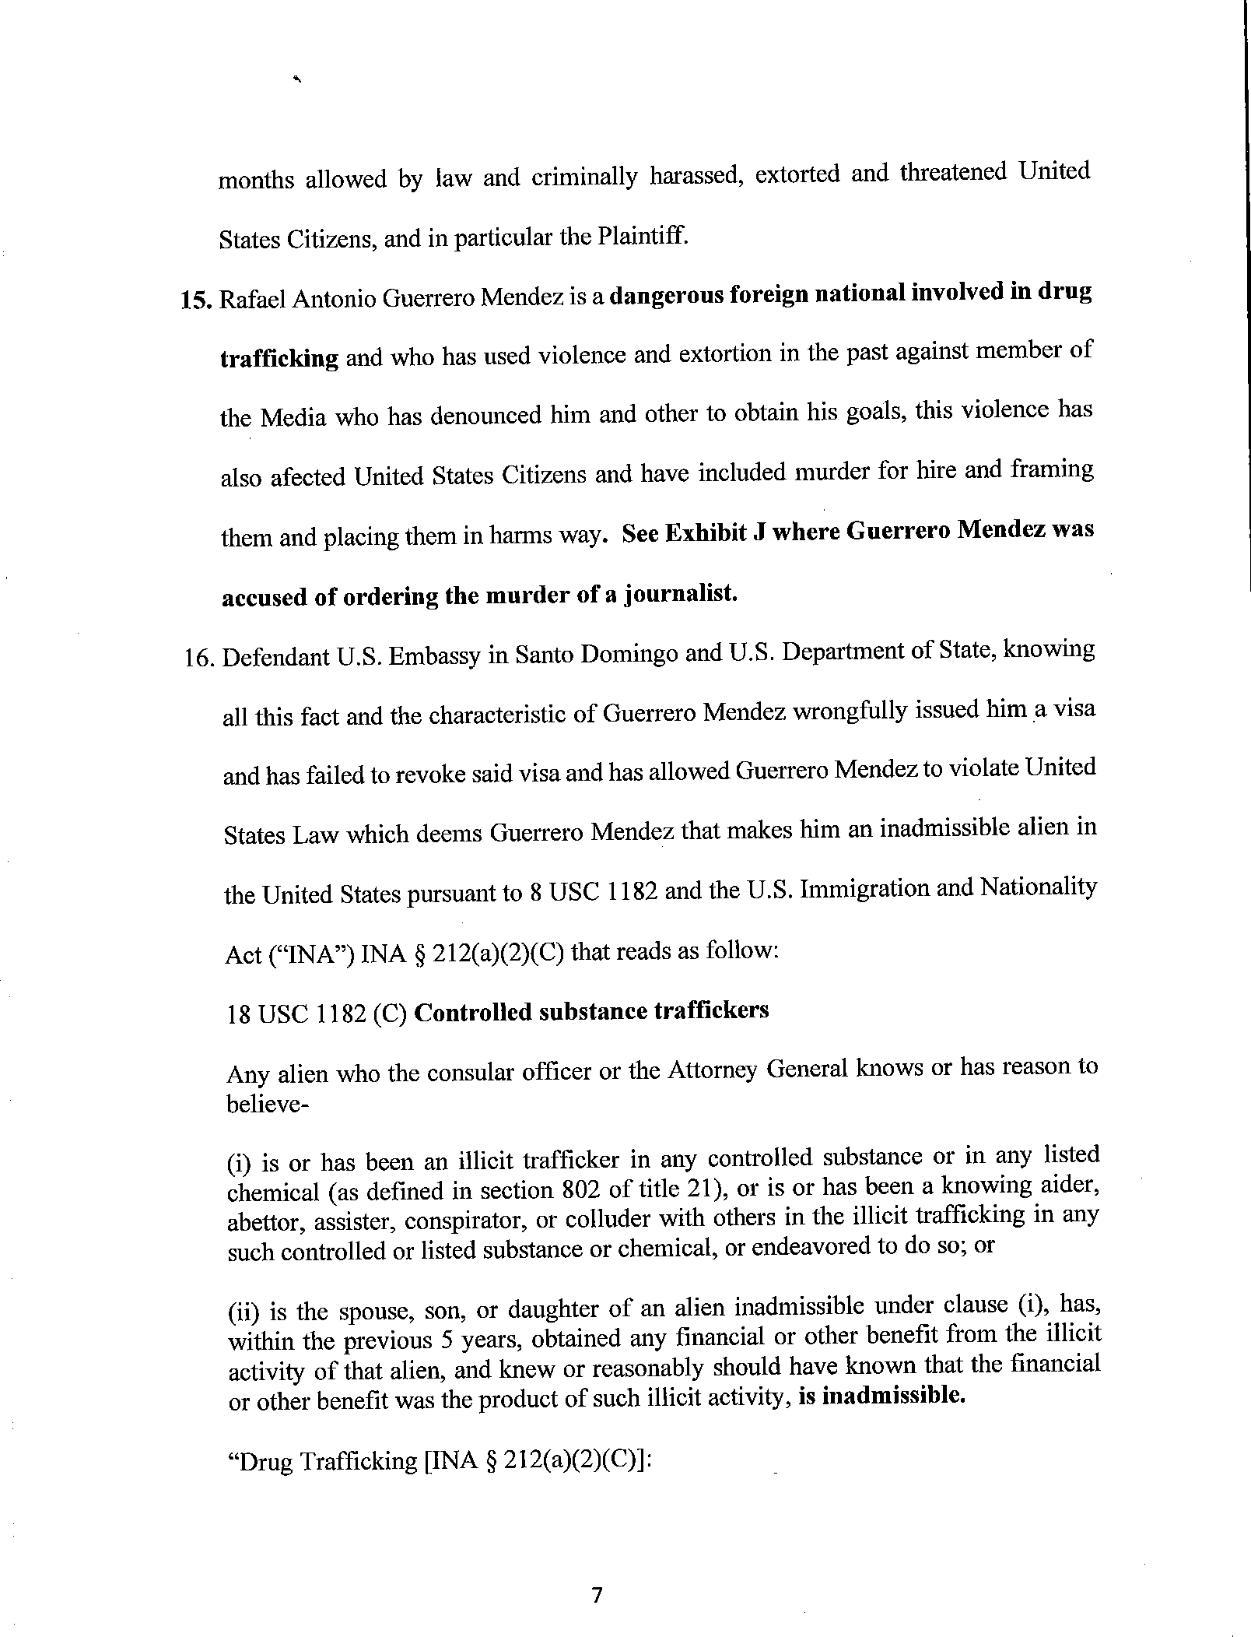
Case 1:21-cv-00292-UA Document 2 Filed 01/13/21 Page 7 of 25

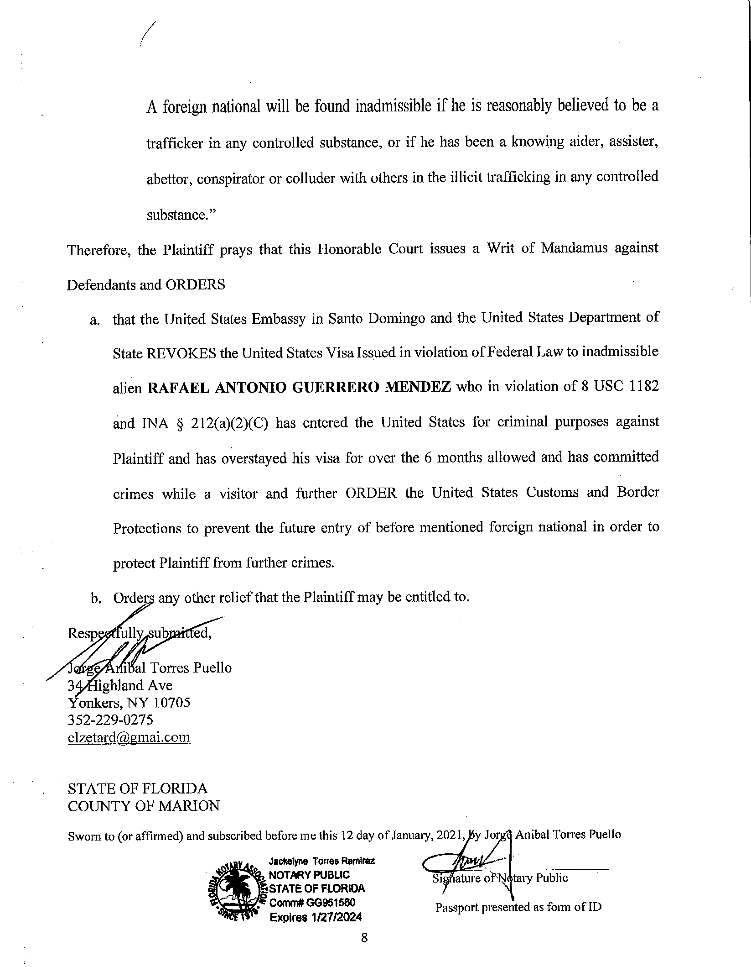
Case 1:21-cv-00292-UA Document 2 Filed 01/13/21 Page 8 of 25

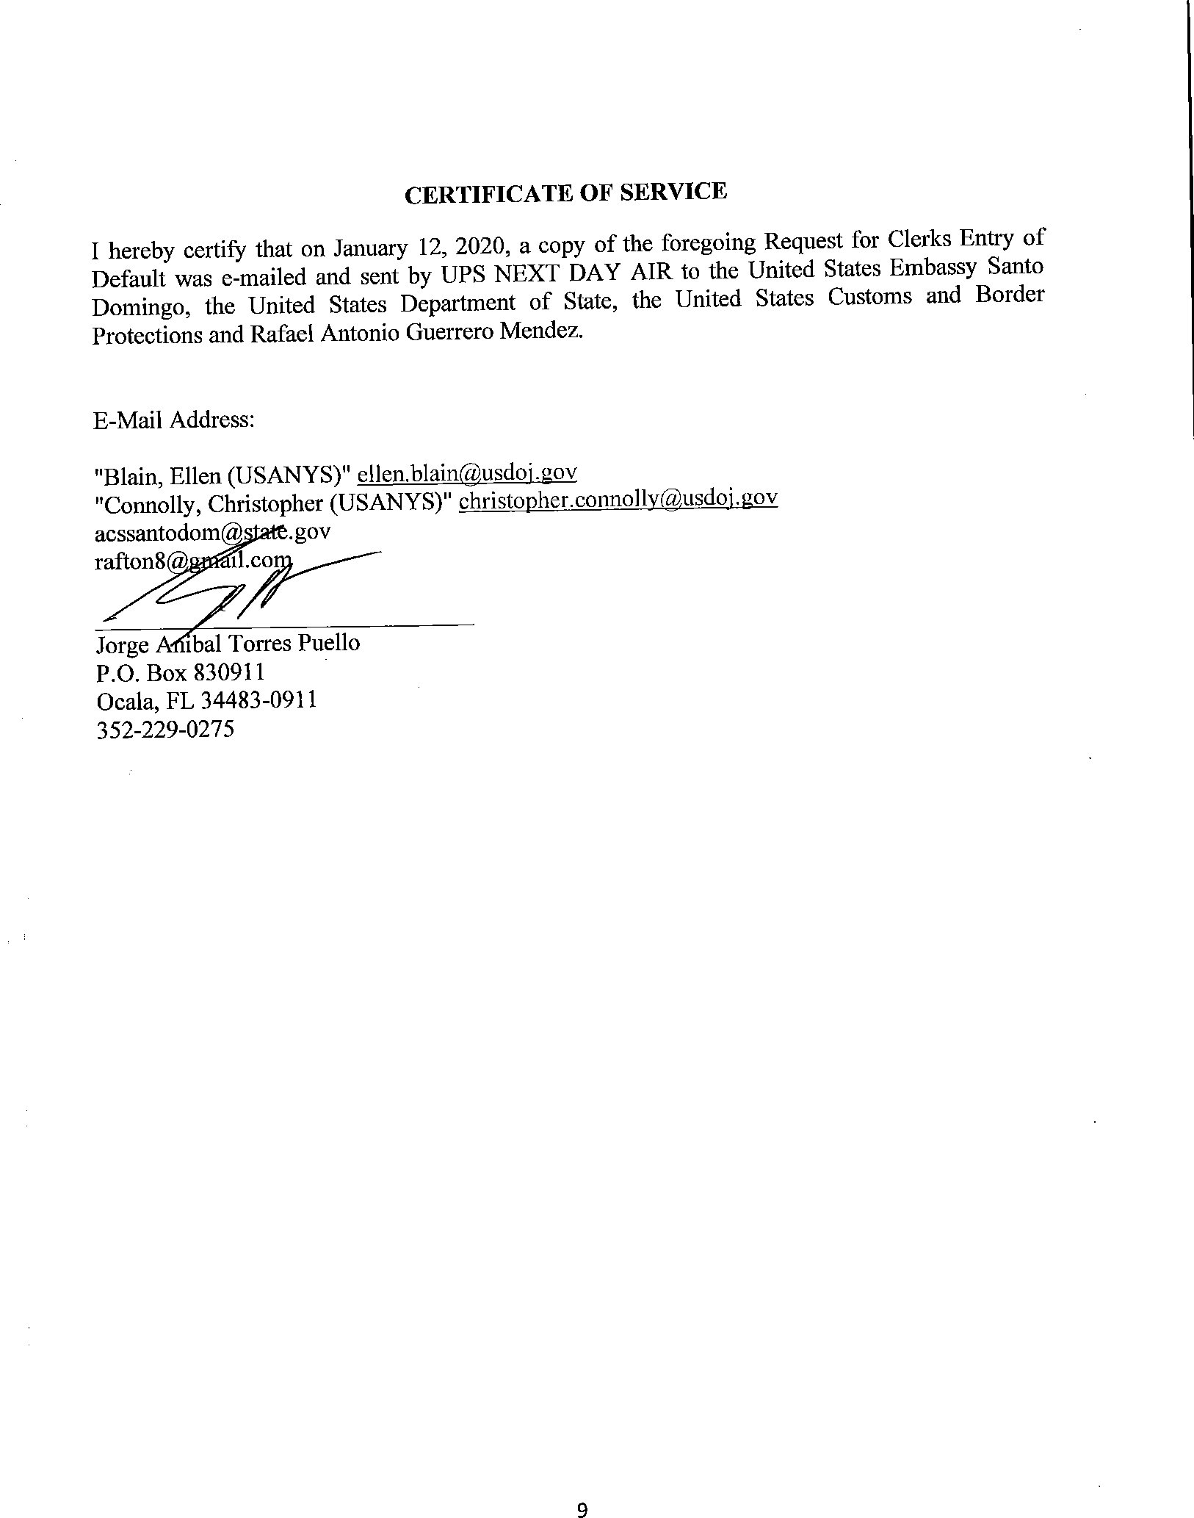
Case 1:21-cv-00292-UA Document 2 Filed 01/13/21 Page 9 of 25

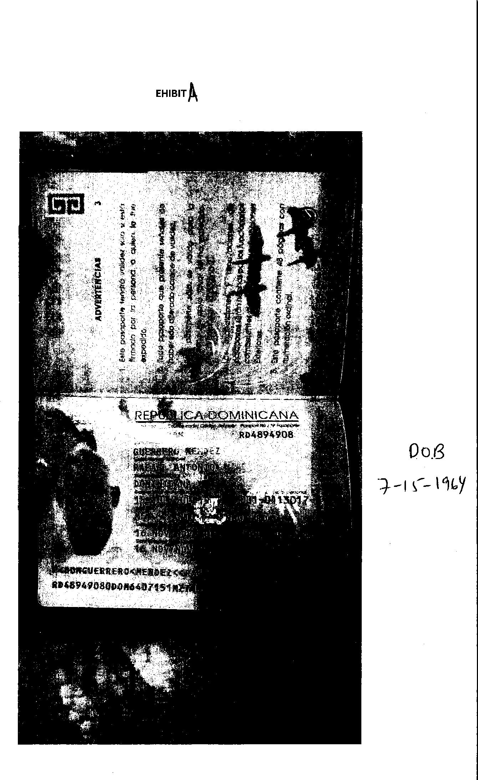
Case 1:21-cv-00292-UA Document 2 Filed 01/13/21 Page 10 of 25

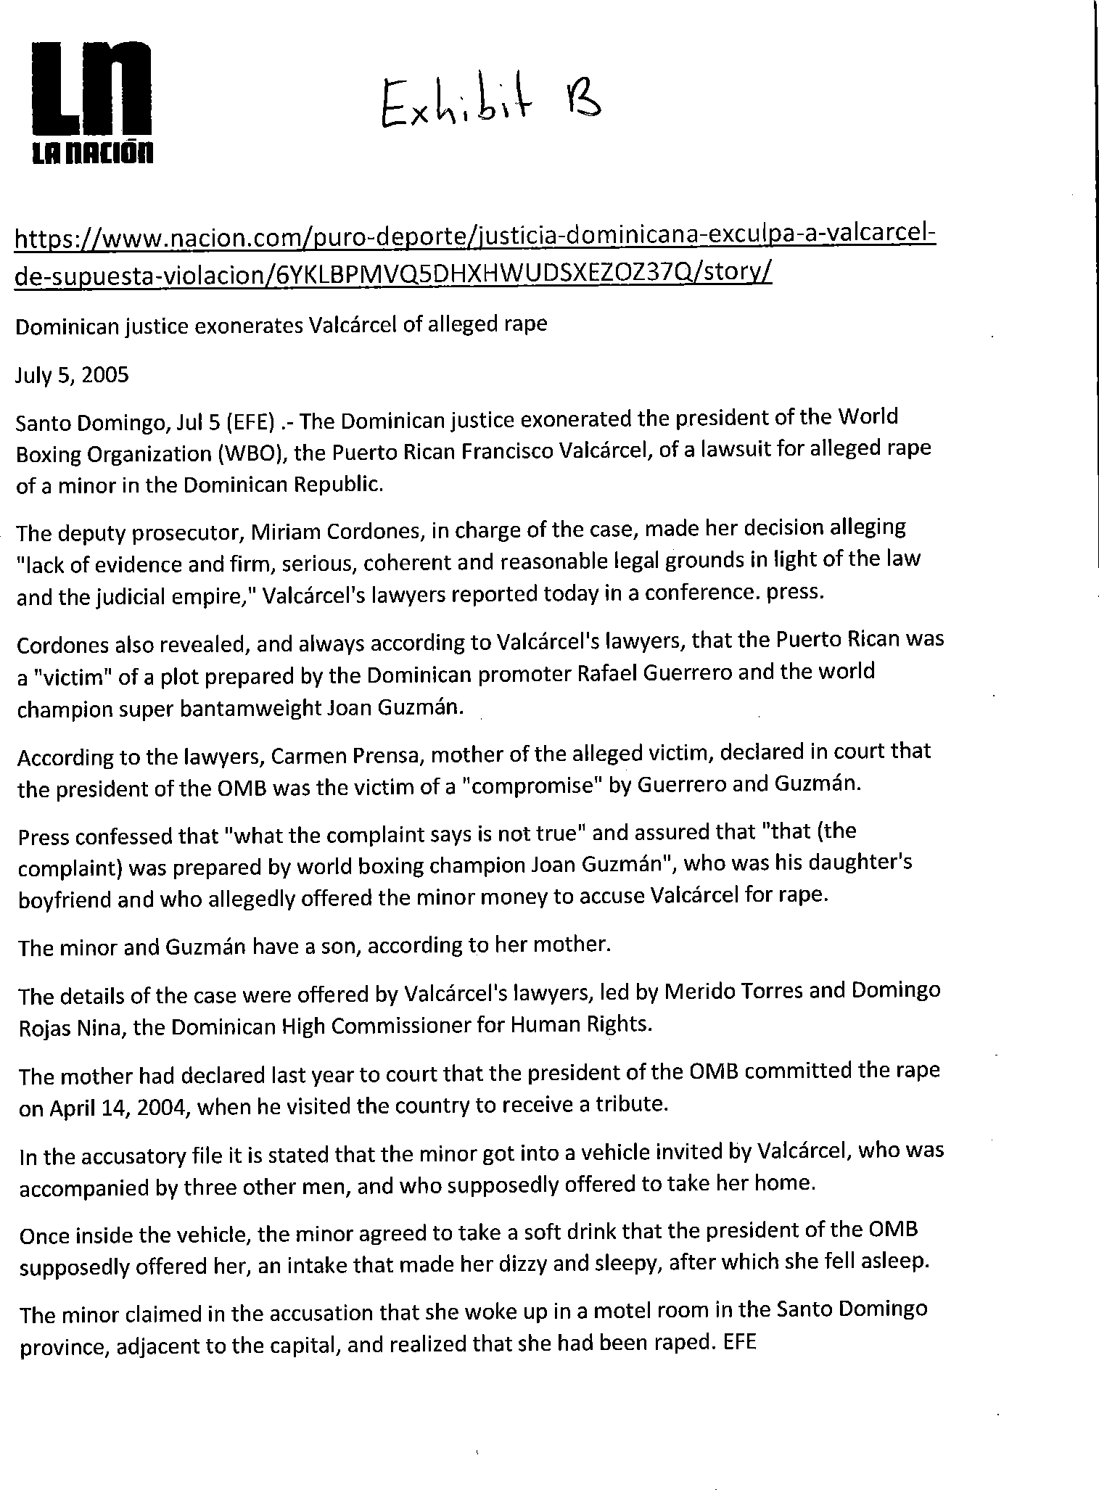
Case 1:21-cv-00292-UA Document 2 Filed 01/13/21 Page 11 of 25

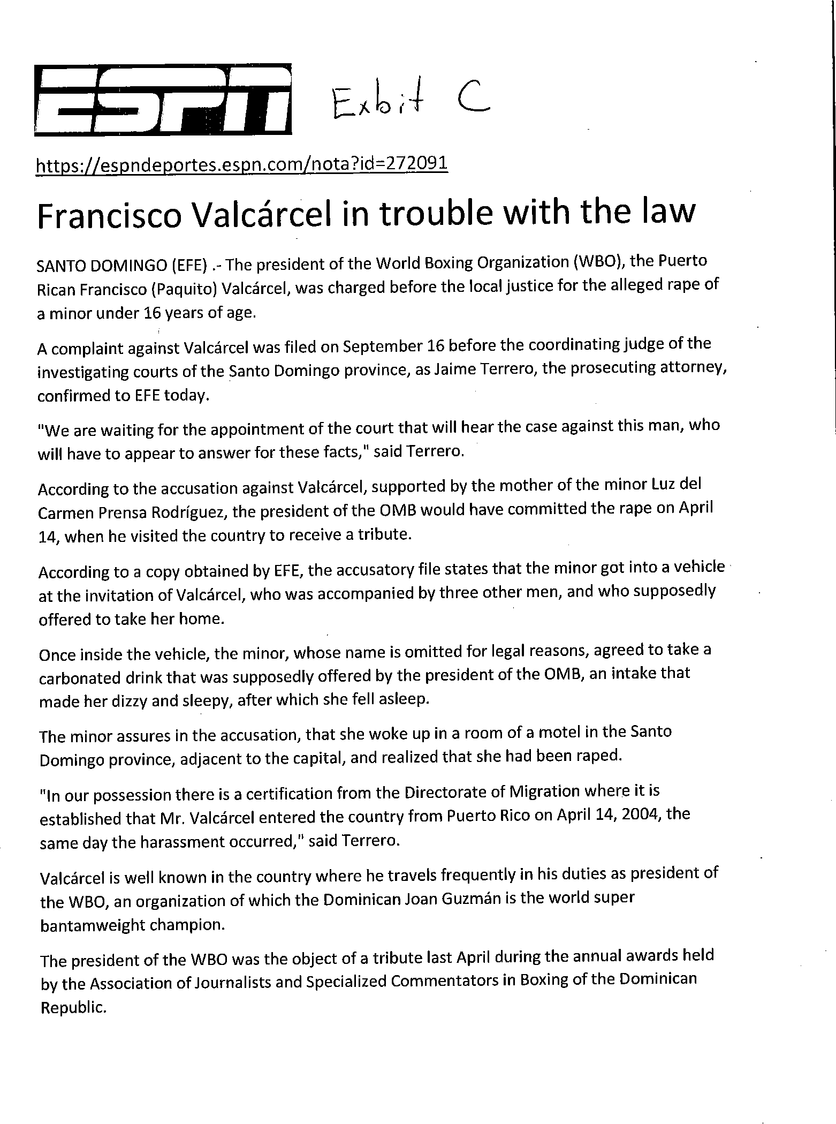
Case 1:21-cv-00292-UA Document 2 Filed 01/13/21 Page 12 of 25

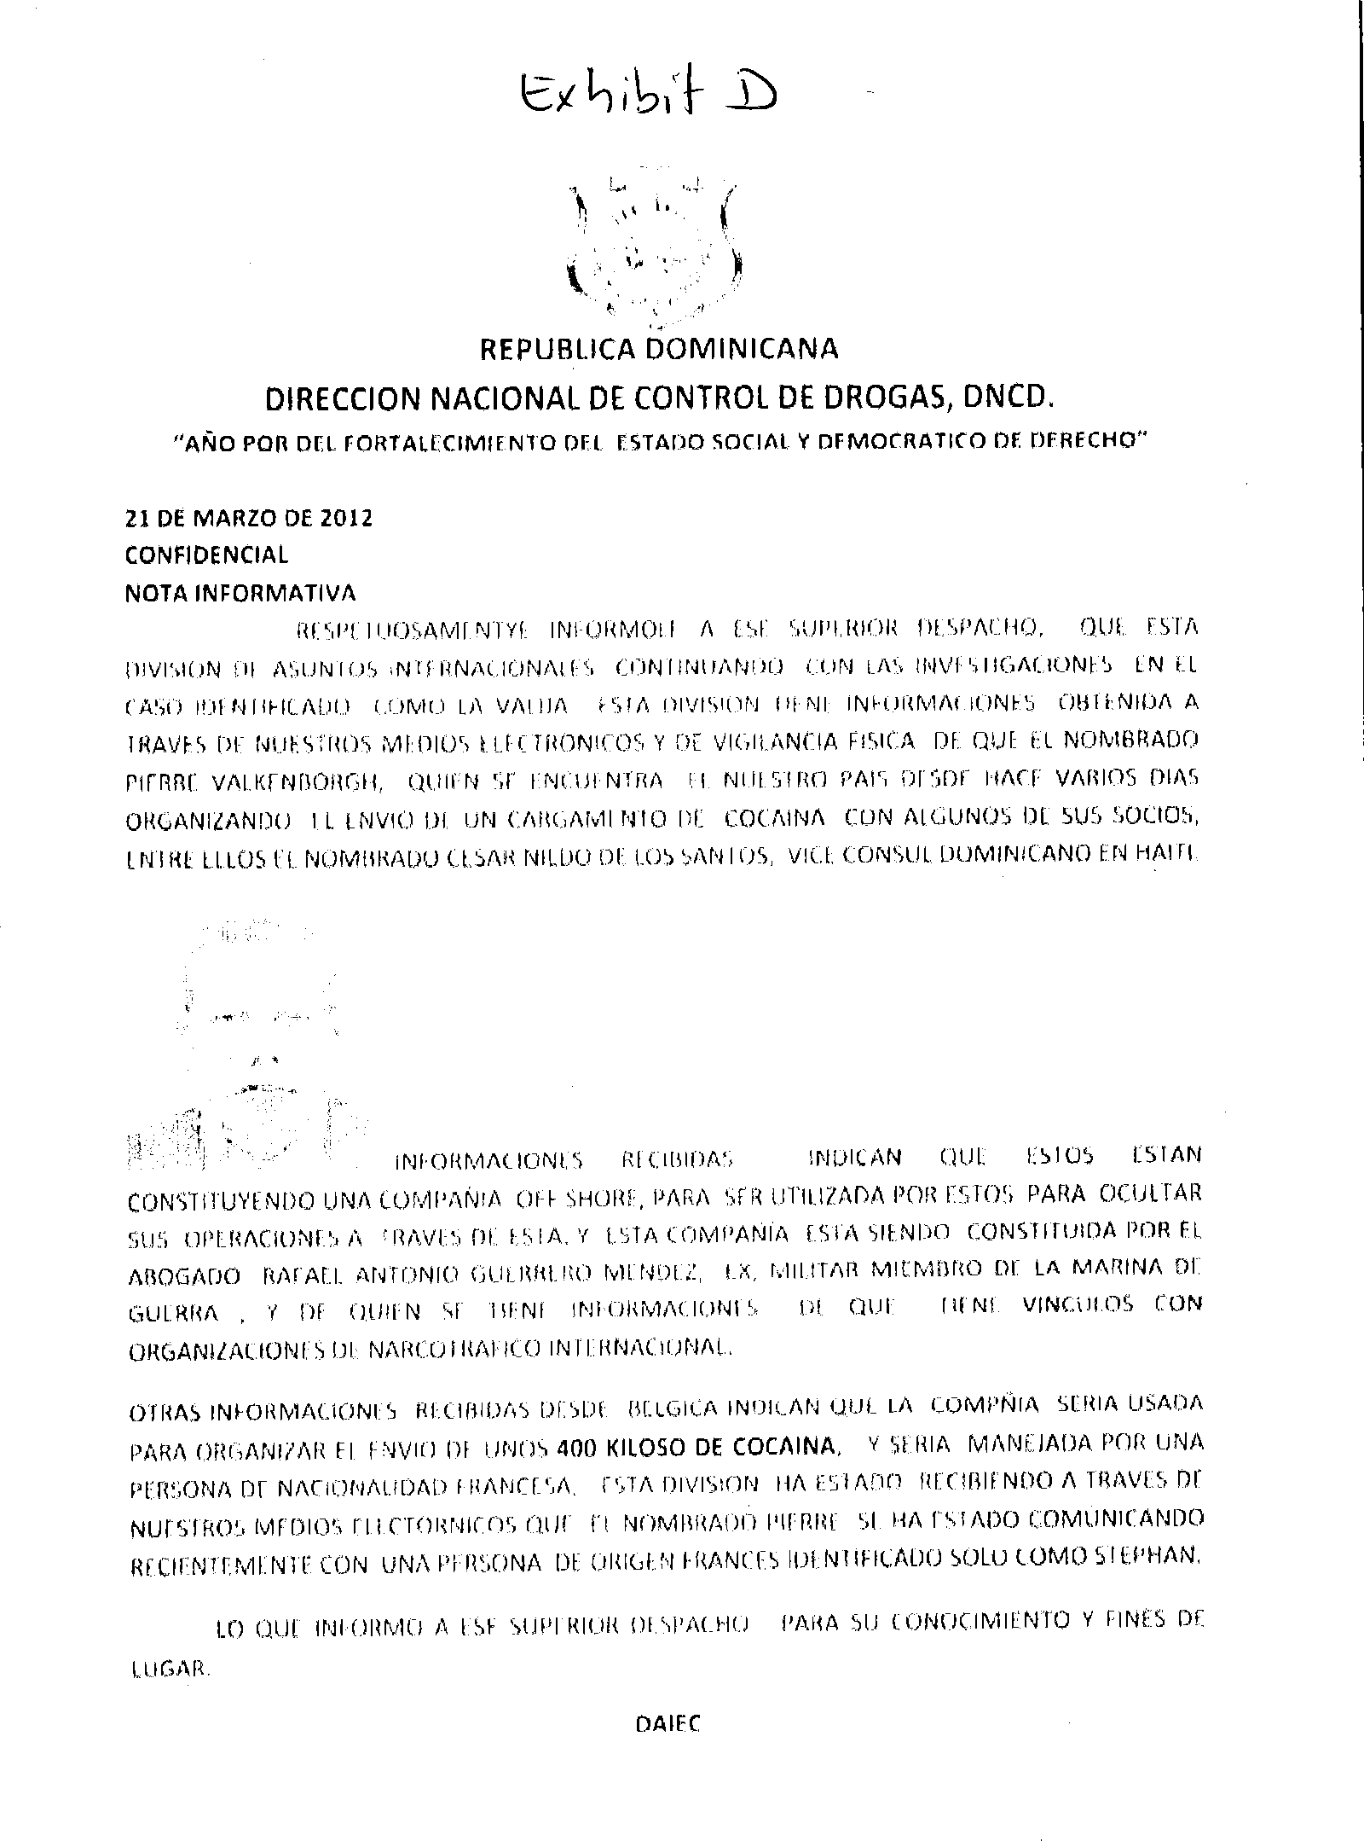
Case 1:21-cv-00292-UA Document 2 Filed 01/13/21 Page 13 of 25

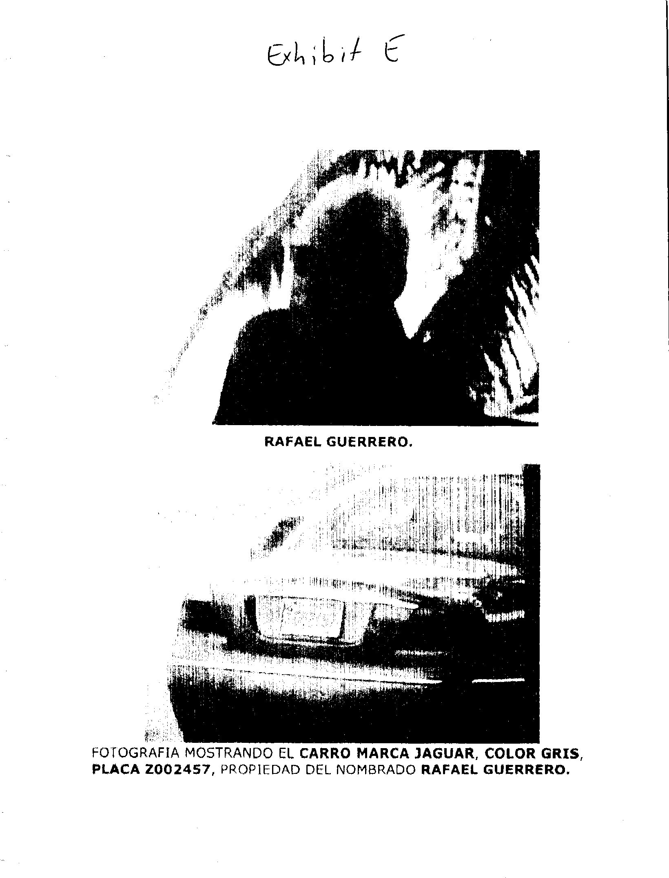
Case 1:21-cv-00292-UA Document 2 Filed 01/13/21 Page 14 of 25

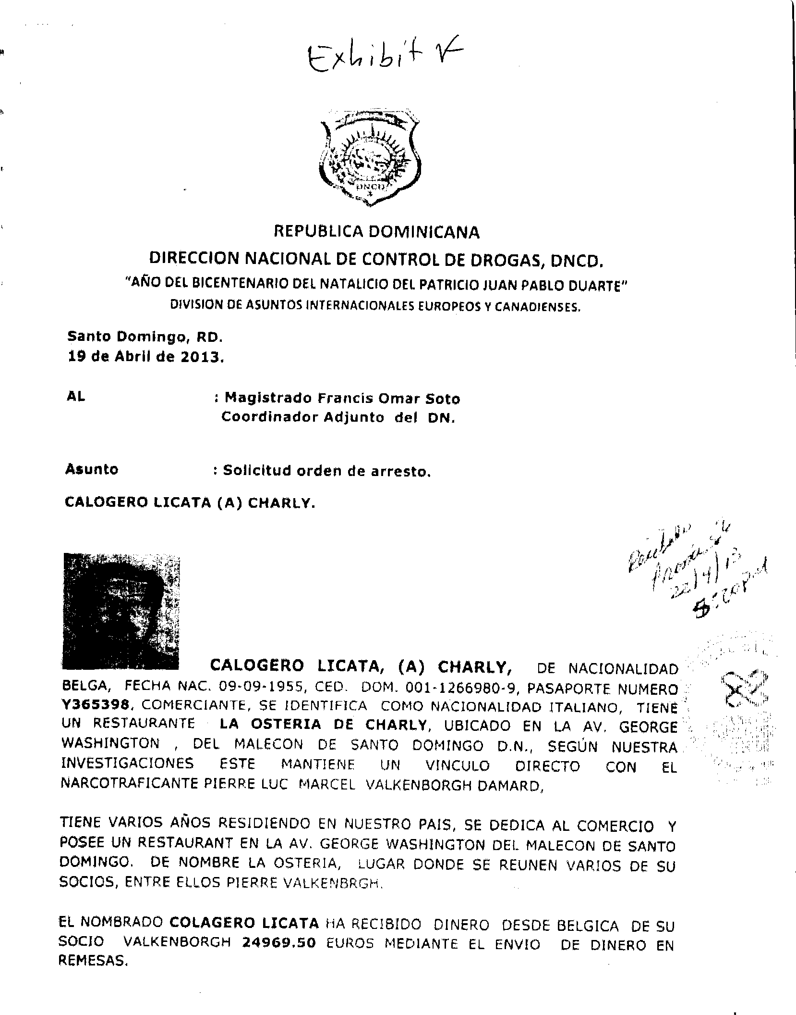
Case 1:21-cv-00292-UA Document 2 Filed 01/13/21 Page 15 of 25

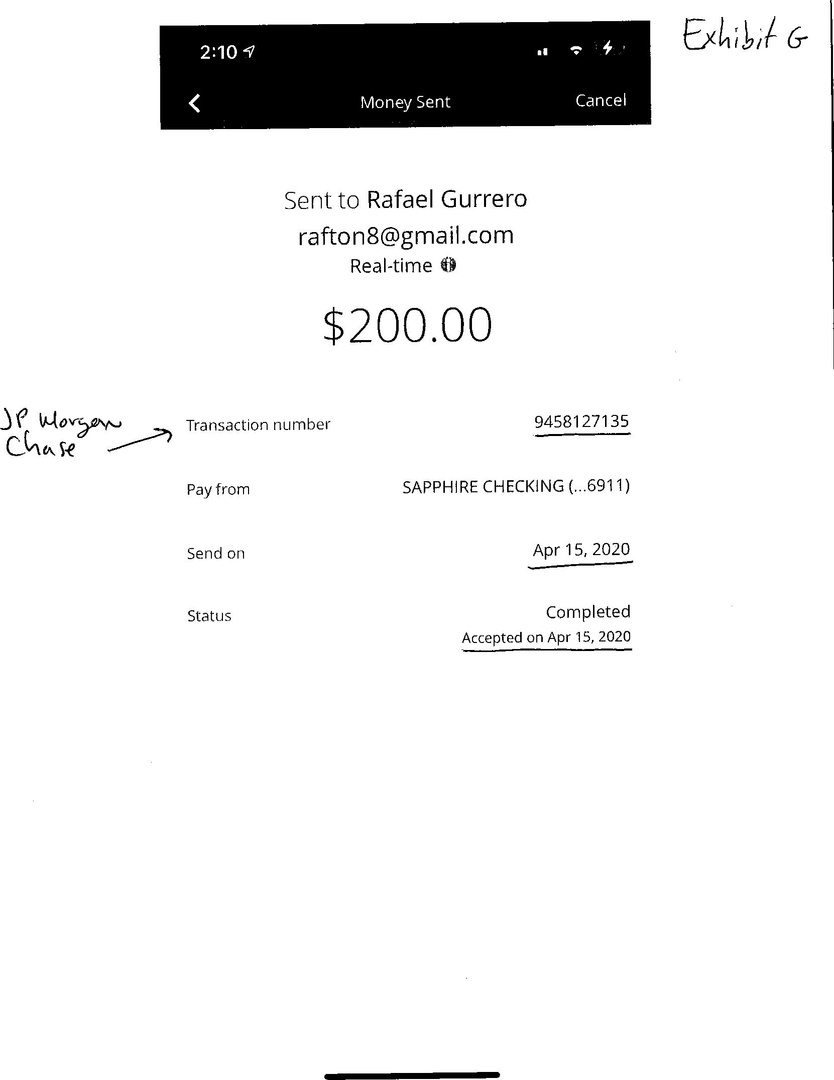
Case 1:21-cv-00292-UA Document 2 Filed 01/13/21 Page 16 of 25

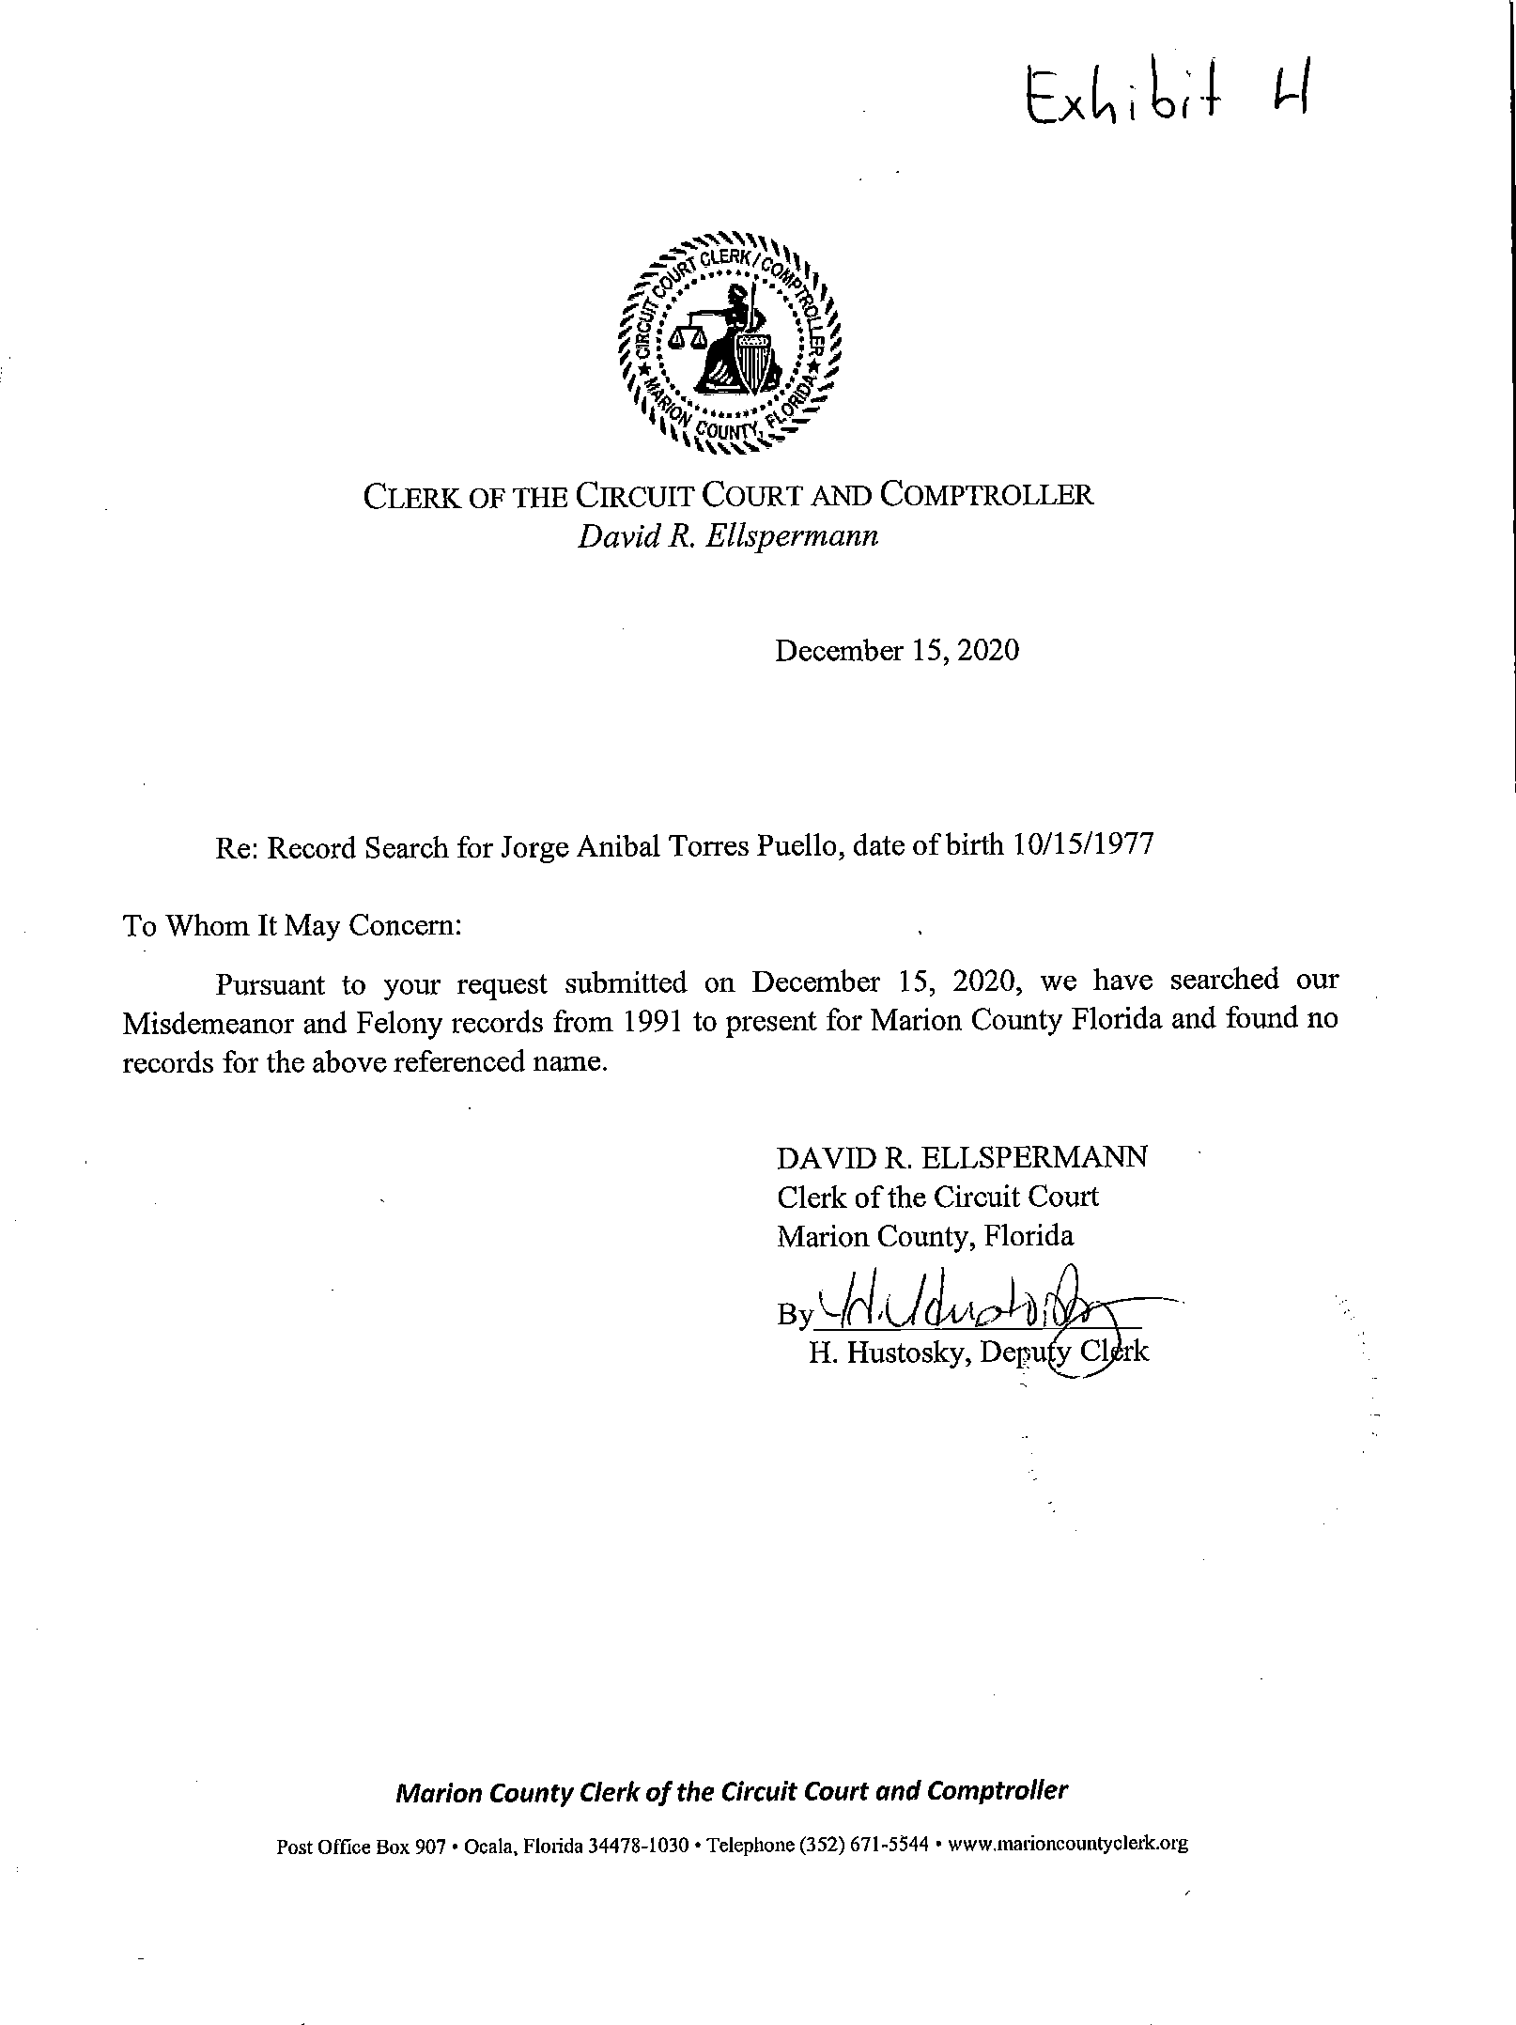
Case 1:21-cv-00292-UA Document 2 Filed 01/13/21 Page 17 of 25

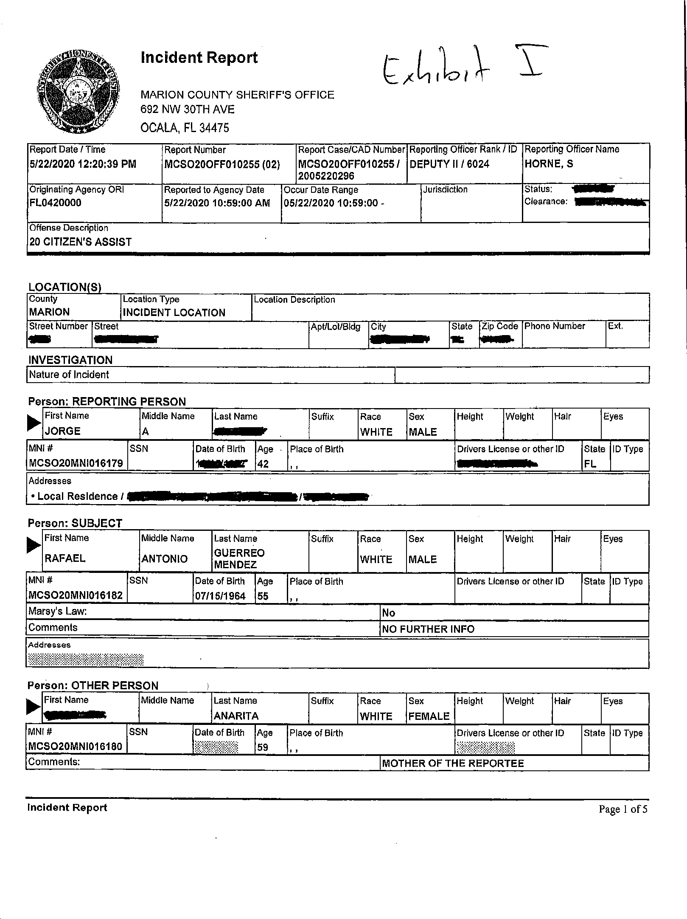
Case 1:21-cv-00292-UA Document 2 Filed 01/13/21 Page 18 of 25

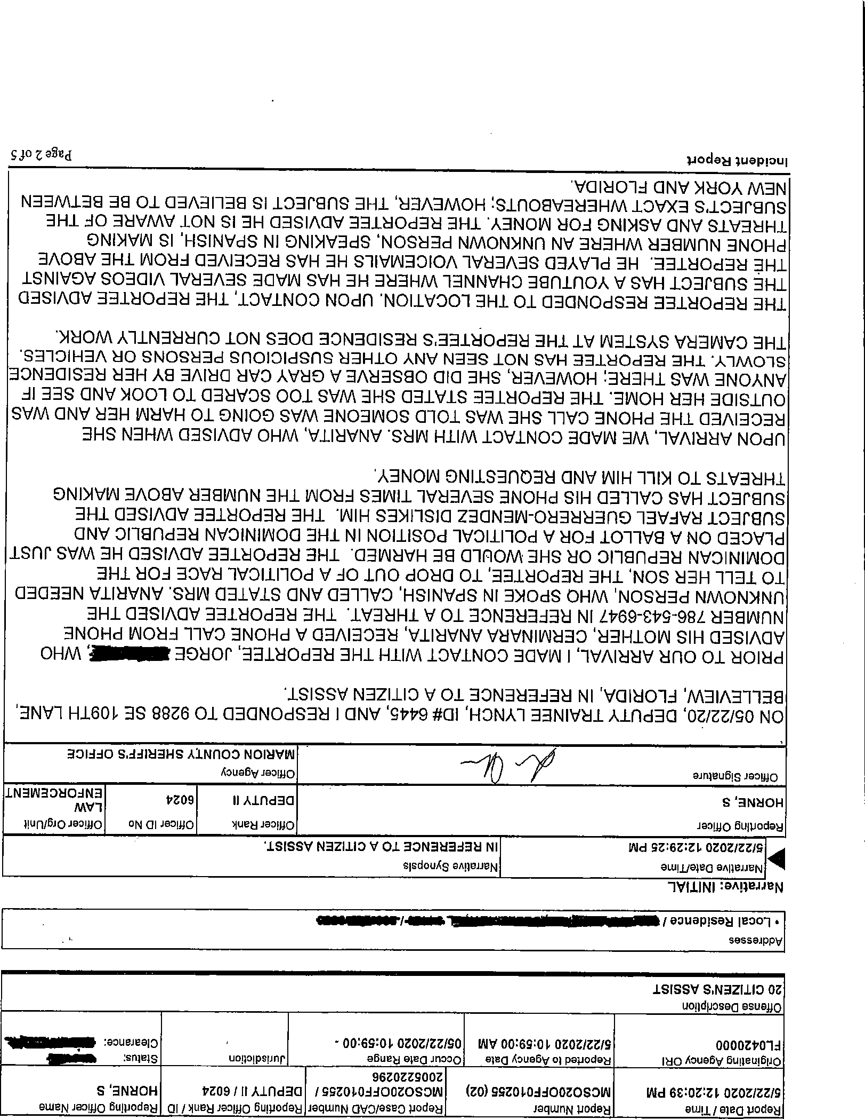
Case 1:21-cv-00292-UA Document 2 Filed 01/13/21 Page 19 of 25

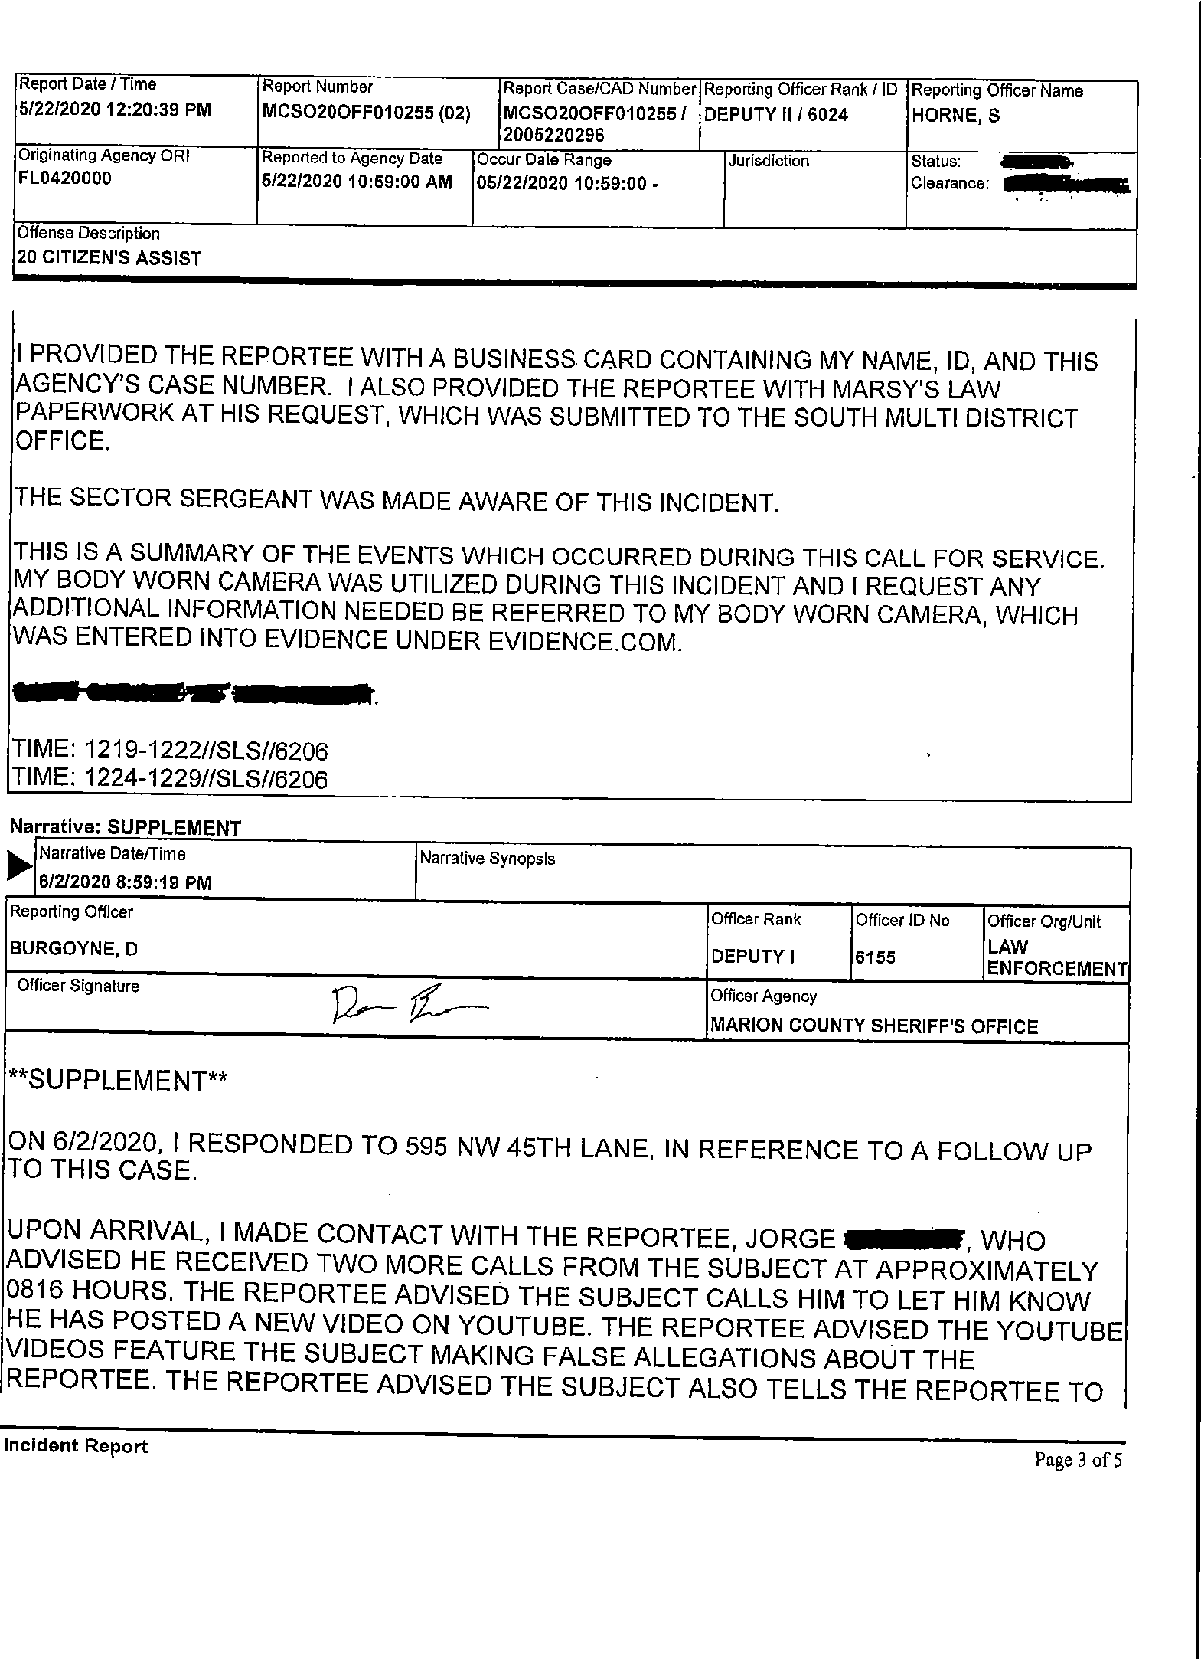
Case 1:21-cv-00292-UA Document 2 Filed 01/13/21 Page 20 of 25

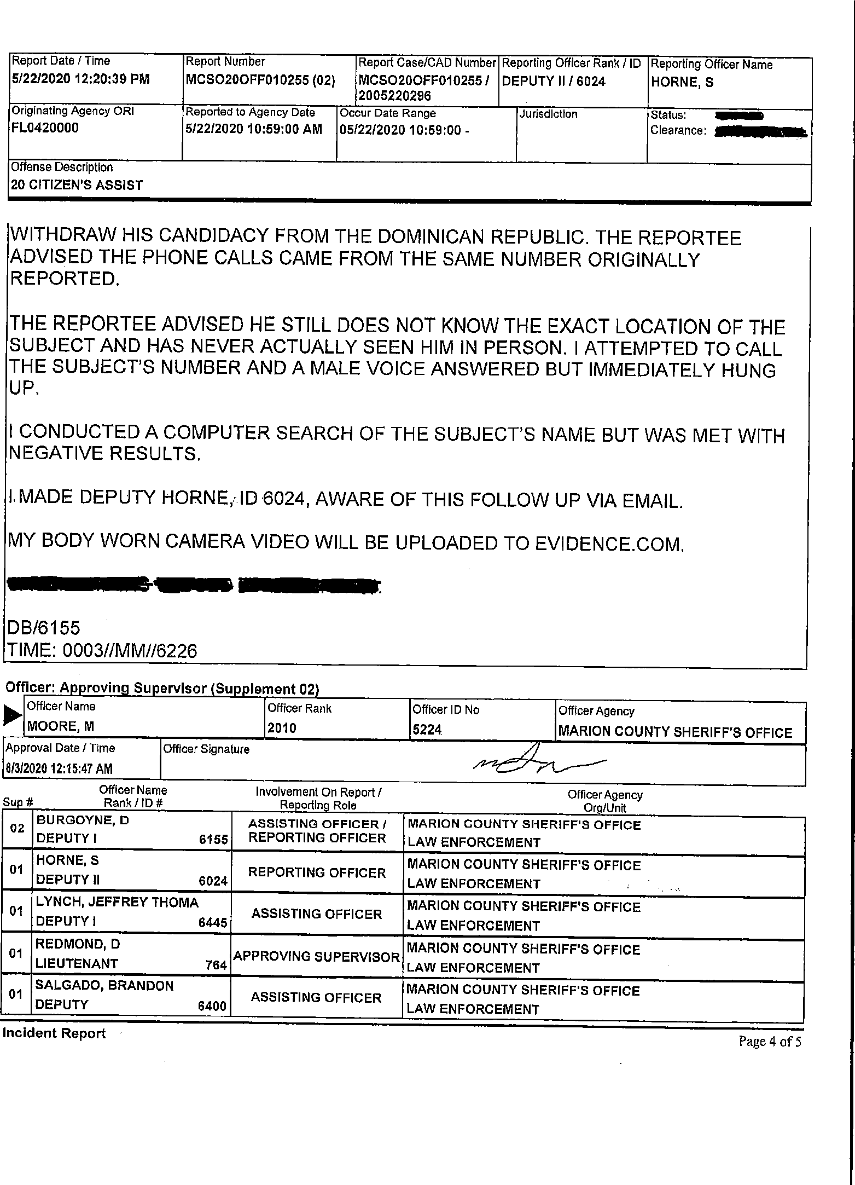
Case 1:21-cv-00292-UA Document 2 Filed 01/13/21 Page 21 of 25

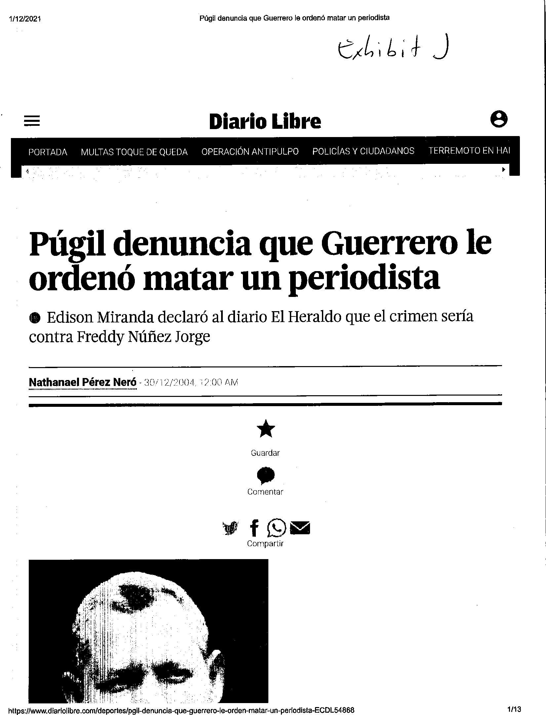
Case 1:21-cv-00292-UA Document 2 Filed 01/13/21 Page 22 of 25

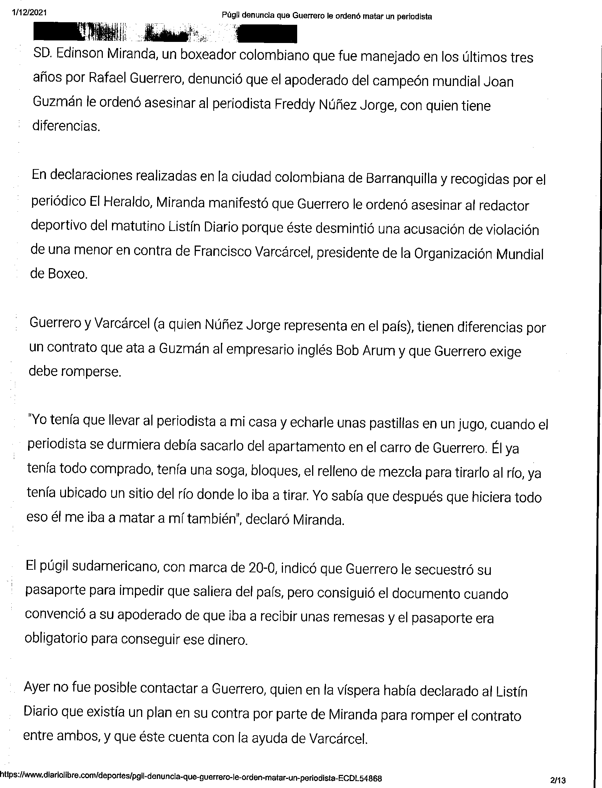
Case 1:21-cv-00292-UA Document 2 Filed 01/13/21 Page 23 of 25

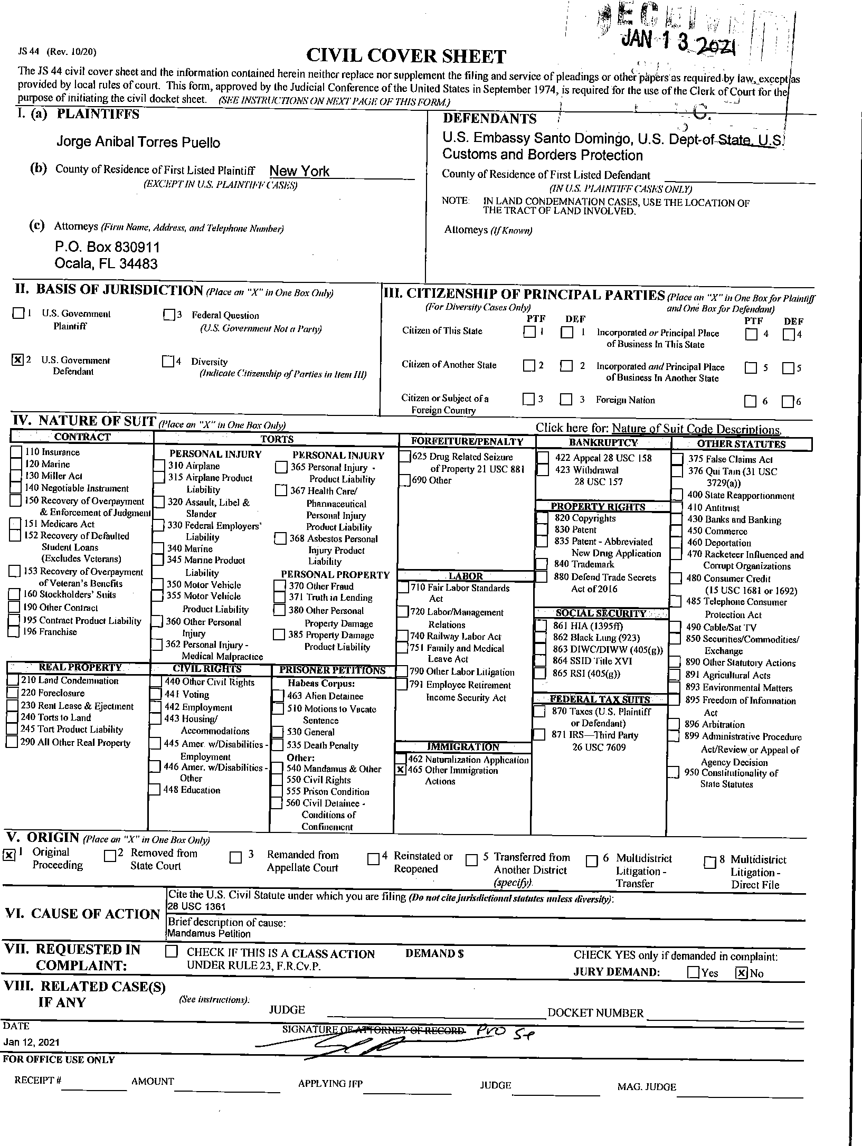
Case 1:21-cv-00292-UA Document 2 Filed 01/13/21 Page 24 of 25

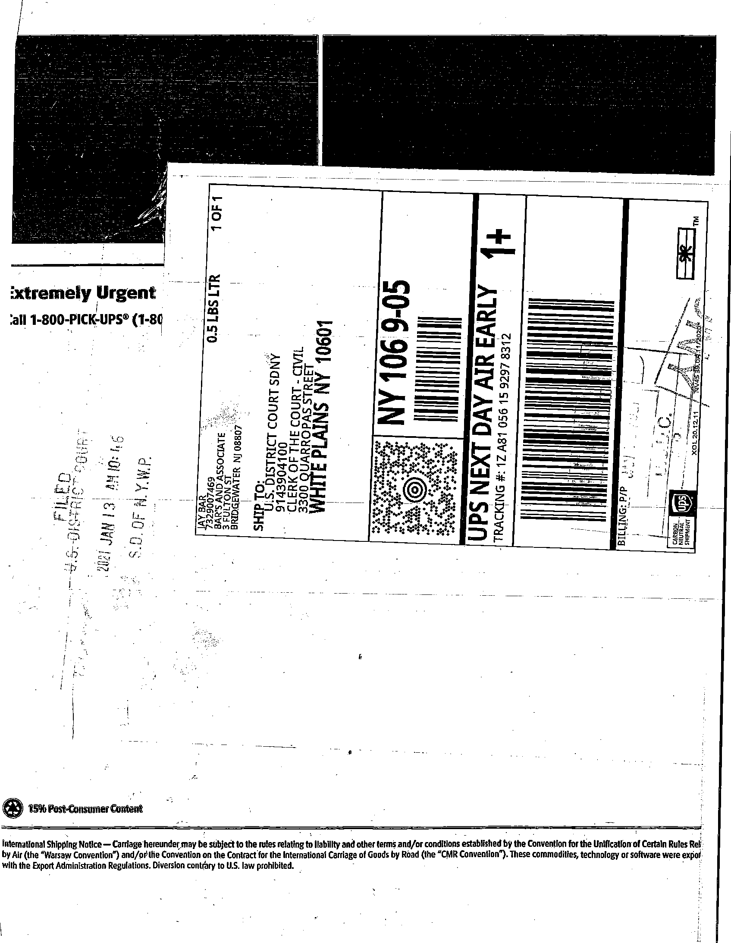
Case 1:21-cv-00292-UA Document 2 Filed 01/13/21 Page 25 of 25

